**KickStarter Analytics**



**By: Howard Mitchell**

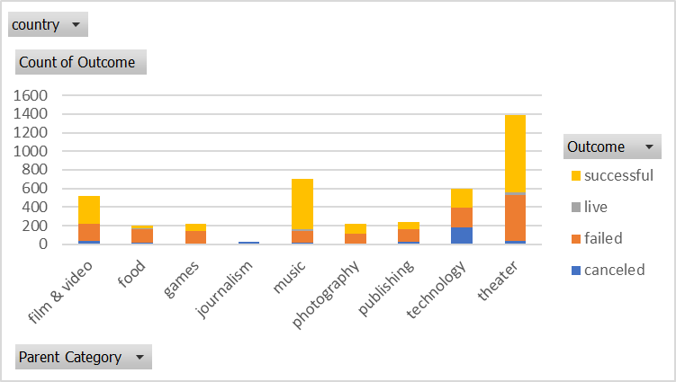

-The above chart shows a clear bias toward theatre projects as far as the number of campaigns on Kickstarter. Music is the second most popular type of Kickstarter campaign followed closely by technology.

-As far as the success rates go, music Kickstarter campaigns appear to have the highest rate of success followed by theatre, and film and video. I have calculated the success rates below:

**-Music:** 540 successful campaigns/ 700 overall = **77.14% Success Rate**

-**Theatre:** 839 successful campaigns/ 1393 overall = **60.23% Success Rate**

**-Film and Video:** 300 successful campaigns/ 520 overall = **57.69% Success Rate**

-Journalism is by far the laggard here. All 24 Journalism projects that were started ended up being canceled, thus leaving a success rate of 0%.

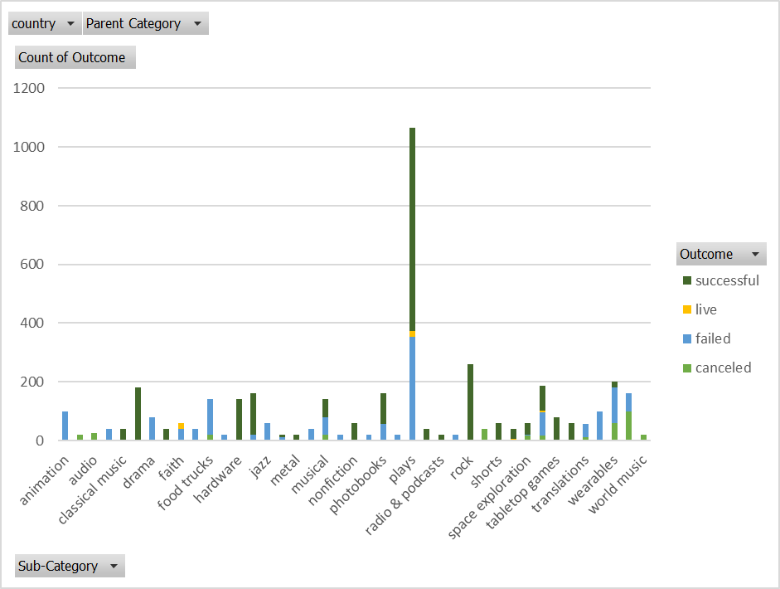

-Given the above information, the plays sub category within the theater parent category is the biggest outlier as far as number of projects go.

-Plays account for an overwhelming majority of the campaigns in the theatre group. Out of 1393 theatre Kickstarter campaigns, 1066 of them are plays. Therefore, plays account for 76.53% of the activity in the theater parent category.

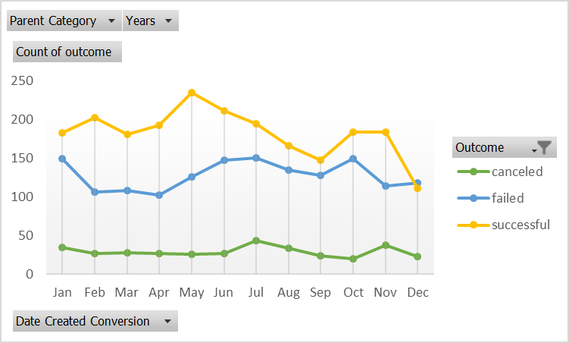

-The month containing the highest number of successful Kickstarter campaigns is May at 234 successful campaigns.

-The month containing the highest number of failed projects is July at 150 failed. This is followed closely by January and October which both have 149 failed projects.

-July and November have the most canceled projects at 43 and 37 respectively.

-Overall, activity seems to roughly be at it’s peak during the 2nd and 4th quarter.

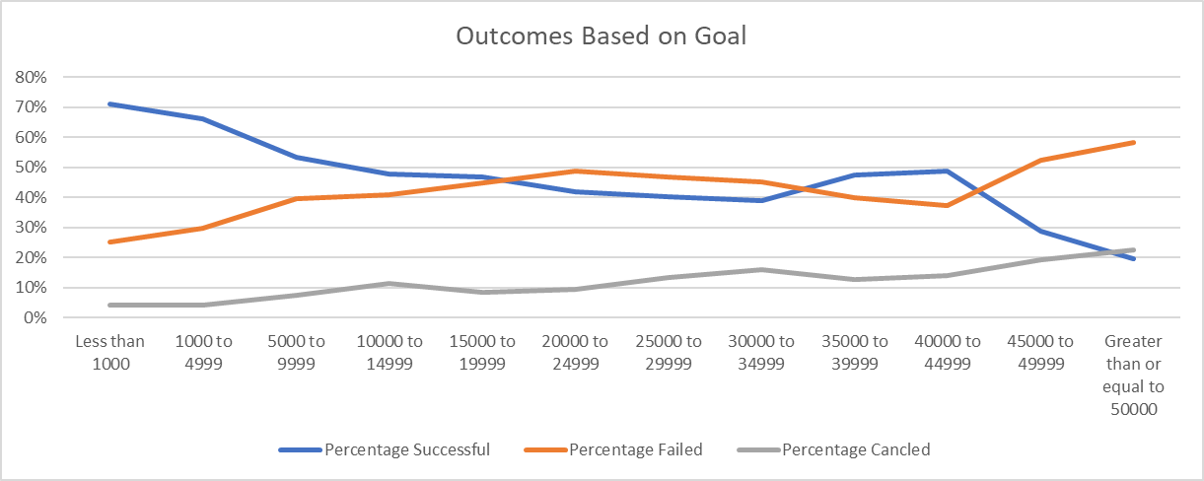

-The data points out a clear correlation between the Goal amount and the overall success rate.

-Projects that have a lower goal amount tend to have a higher probability of success.

-Inversely, projects that higher goal amount tent to have a higher probability of failure.

-The peak rate of success in relation to goal amount is 71% with campaigns having goals that are less than $1,000.

-The peak rate of failure in relation to goal amount is 58% with campaigns having goals that are above $50,000.

-As far as candled projects go overall, the higher the goal amount, the higher the probability of cancelation.

-Per the previous post, a good sweet spot where this tends to plateau and the severity of the trending slope flattens is between goal amounts of $10,000 to $40,000. These hover roughly between a 40% and 50% chance of success.

**Summary**

**What are three conclusions we can make about Kickstarter campaigns given the provided data?**

-Given the data one conclusion we can make about Kickstarter campaigns is that Theatre projects are, by far, the most prolific category of campaigns on Kickstarter.

-Although, it is not the most prolific project type on Kickstarter, music has the overall highest success rate at a circa 77.14% Success Rate.

-From the goal/ monies raised standpoint, if you want your project to have a greater than 50% chance of being fully funded, it is best to keep the goal between $0 and circa $7,500 with the highest rate of success being Kickstarter campaigns with goals of less than $1,000 (71% success)

**What are some of the limitations of this dataset?**

-It would be helpful if we had some sort of indicator as to weather or not this was a first campaign by the publishers or if they have released any other successful campaigns in the past.

-It would also be interesting to have information on what the supporters received by backing projects so we could infer what influence that had on success rates. Did they receive a product (if so what was the monetary value), equity, producer credits etc… ?

**What are some other possible tables/graphs that we could create?**

-We could create a table showing the highest distribution of big money donations. (i.e. Any campaign that had an average donation size of $100 or more)

- We could also create charting around the average length of the funding period for the projects. We could chart this around categories and or the size of the goal.

-Charting could be created around the countries the Kickstarter projects were designated in.

-There could also be a chart created to show the success rate and categories of any project that was a “Staff Pick”.